Chapter 27-3

java collections framework

Interface Map<K,V>

- Interface Map does not inherit Collection.
- Interface Map takes 2 type parameters, K and V
  - K specifies the type of the keys
  - V specifies the type of the elements.
- Interface Map associates keys with elements.
  - Every element stored in a Map is associated with a unique key.
  - A key and its associated element together are called an entry in the Map, of type Map.Entry<K,V>
  - We look up an element in a Map using a key.
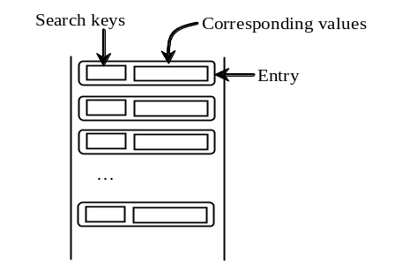

// Many applications may use a map instead of something like a TreeSet because of easy retrieval (student ID as the key, for example)
// A Map does not allow duplicate keys

---------------------------------------------------------------------------------------------------------------------
Usage: void clear();
Post: All elements from this Map removed.

Usage: int size();
Return: The number of elements in this Map.

Usage: boolean isEmpty();
Return: True if this Map contains no elements; false otherwise.

Usage: boolean containsKey(Object key);
Return: True if this Map contains an entry with the specified key; false otherwise.

Usage: V remove(Object key);
Post: The entire entry specified by key removed if exists
Return: The value component of the entry specified by key if entry exists; null if entry does not exist.

Usage: V put(K key, V newValue);
Post: The value component of the entry specified by key replaced by newValue if entry exists; the new entry pair (key, newValue) added if entry does not exist
Return: The old value component of the entry specified by key if entry exists; null if entry does not exist.

Usage: V get(Object key);
Return: The value component of the entry specified by key if entry exists; null if entry does not exist

Usage: Set<K> keySet();
Return: A Set object of all the keys contained in this Map. The Set is backed by the Map, so changes to the Map are reflected in the Set, and vice-versa

Usage: Set<Map.Entry<K,V>> entrySet();
Return: A Set object of all the Map.Entry entries contained in this Map. The Set is backed by the Map, so changes to the Map are reflected in the Set, and vice-versa
---------------------------------------------------------------------------------------------------------------------
Figure 27-3-1. Some methods defined in the Map<K,V> interface.

Class HashMap<K, V>

- Class HashMap is a concrete class that implements Map.
  - It can be used to store unique entries (each entry has a unique key)
  - It uses a hashing scheme to efficiently store and retrieve elements in the collection, running at O(1) efficiency.
  - The type K must override hashCode.
  - Objects stored in a HashMap are not ordered in any way.
- A HashMap object supports all the methods specified in interface Map as well as a no-argument constructor.

//Example 27-3-1
//Demo.java
import java.util.*;
public class Demo
{
public static void main(String[] args)
{
HashMap<String, Integer> m=new HashMap<String, Integer>();
m.put("Math", 50);
m.put("CS", 40);
m.put("Educ", 40);
m.put("Math", 25);
System.out.println(m);
System.out.println("Education has " + m.get("Educ") + " majors");
}
}
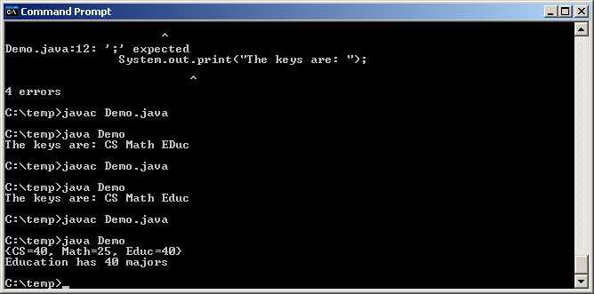

- A Map object has a toString method which returns a string in the form of {key₁=value₁, key₂=value₂, …}.

//Example 27-3-2
//Demo.java
import java.util.*;
public class Demo
{
public static void main(String[] args)
{
HashMap<String, Integer> m=new HashMap<String, Integer>();
m.put("Math", 50);
m.put("CS", 40);
m.put("Educ", 40);
System.out.print("The keys are: ");
Set<String> keySetObj=m.keySet();
Iterator<String> iterK= keySetObj.iterator();
while (iterK.hasNext())
System.out.print(iterK.next()+" ");
System.out.println();
}
}
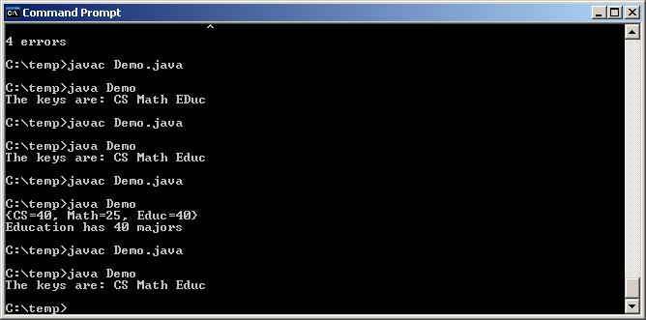

Interface Map.Entry<K,V>

- The Map interface defines a nested interface, Map.Entry<K,V> .
- The entrySet method of a Map returns a set of all entries in the Map, each of type Map.Entry<K,V>.

//Example 27-3-3
//Demo.java
import java.util.*;
public class Demo
{
public static void main(String[] args)
{
HashMap<String, Integer> m=new HashMap<String, Integer>();
m.put("Math", 50);
m.put("CS", 40);
m.put("Educ", 40);
System.out.print("The entries are: ");
Set<Map.Entry<String, Integer>> entrySetObj=m.entrySet();
Iterator<Map.Entry<String, Integer>> iterE= entrySetObj.iterator();
while (iterE.hasNext())
System.out.print(iterE.next()+" ");
System.out.println();
}
}
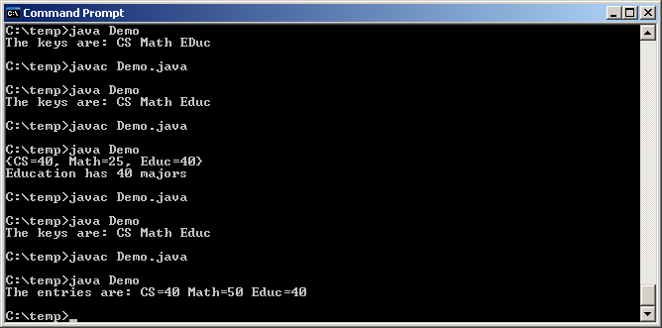

- A Map.Entry object has a toString method returns a string in the form of key=value.

---------------------------------------------------------------------------------------------------------------------
Usage: K getKey();
Return: The key of this entry

Usage: V getValue();
Return: The value of this entry

Usage: V setValue(V newValue);
Post: The value of this entry replaced by newValue
Return: The old value of this entry
---------------------------------------------------------------------------------------------------------------------
Figure 27-3-2. Some methods defined in the Map.Entry<K,V> interface.

//Example 27-3-4
//Demo.java
import java.util.*;
public class Demo
{
public static void main(String[] args)
{
HashMap<String, Integer> m=new HashMap<String, Integer>(); //line 8
m.put("Math", 50);
m.put("CS", 40);
m.put("Educ", 40);
Set<Map.Entry<String, Integer>> entrySetObj=m.entrySet();
Iterator<Map.Entry<String, Integer>> iterE= entrySetObj.iterator();
while (iterE.hasNext())
{
Map.Entry<String, Integer> ele=iterE.next();
if (ele.getKey().equals("CS")) ele.setValue(70);
}
System.out.println(m);
}
}
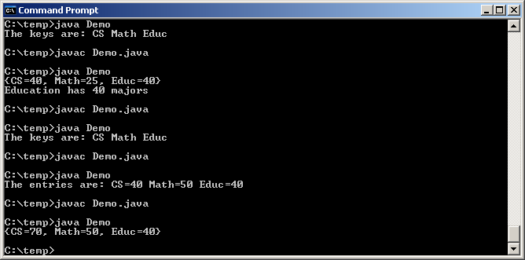

Interface SortedMap<K,V>

---------------------------------------------------------------------------------------------------------------------
Usage: K firstKey();
Return: The first (minimum) key currently in this SortedMap
Exeptn: Throws NoSuchElementException if SortedMap is empty

Usage: K lastKey();
Return: The last (maximum) key currently in this SortedMap
Exeptn: Throws NoSuchElementException if SortedMap is empty

Usage: SortedMap<K,V> headMap(K key)
Return: A SortedMap that contains entries in this SortedMap whose keys are < key.

Usage: SortedMap<K,V> tailMap(K key)
Return: A SortedMap that contains elements in this SortedMap whose keys are >= ele.
---------------------------------------------------------------------------------------------------------------------
Figure 27-3-3. Some methods defined in the SortedMap interface.

Class TreeMap<K,V>

- Like a HashMap:
  - It can be used to store unique entries (each entry with a unique key)
  - A TreeMap supports the operations specified in the Map interface.
  - An entry of a TreeMap object supports all the methods specified in interface Map.Entry<K,V>.
- Unlike a HashMap:
  - A TreeMap implements the SortedMap interface as well.
  - The entries in a TreeMap are ordered based on the keys. You can use an iterator to traverse the elements in the sorted order.
  - A TreeMap uses a binary search tree scheme (instead of a hashing scheme) to efficiently store and retrieve elements in the collection, running at O(log n) efficiency.
- A TreeMap object supports all the methods specified in interfaces Map and SortedMap, as well as a no-argument constructor.
- We can use either a HashMap or a TreeMap to store elements. The decision as to which one to use is typically based on the following:
  - Many HashMap methods run at O(1), while the corresponding TreeMap methods run at O(log n).
  - HashMap elements are not ordered, but TreeMap elements are.
- Once the decision of whether to use a HashMap or a TreeMap has been made, we must turn our attention to the class type K of the keys to be stored in the collection to make sure that it works with the selected collection:
  - The class type K of the keys used with a HashMap
    - Does not need to implement Comparable, because the elements in a HashMap are not ordered in any particular way.
    - Does need to override method hashCode.
  - The class type K of the keys used with a TreeMap
    - Does need to implement Comparable if the TreeMap is constructed using the no-argument constructor, because the elements in a TreeMap are ordered.
    - Does not need to override method hashCode.
- Change line 8 of Example 27-3-4 to the following (we are replacing both occurrences of HashMap by TreeMap):
TreeMap<String, Integer> m=new TreeMap<String, Integer>(); //line 8
- Compile and run the program:
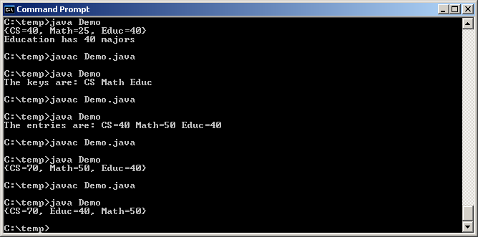

- You can construct a TreeMap passing in a Comparator for comparing keys:
public TreeMap(Comparator<? super K> comparator)
- Of course, a TreeMap possesses those methods specified in the SortedMap interface, which a HashMap does not possess.

//Example 27-3-5
//Demo.java
import java.util.*;
public class Demo
{
public static void main(String[] args)
{
TreeMap<String, Integer> m=new TreeMap<String, Integer>();
m.put("Math", 50);
m.put("CS", 40);
m.put("Educ", 40);
System.out.println(m.firstKey());
System.out.println(m.lastKey());
System.out.println(m.headMap("Econ"));
System.out.println(m.tailMap("Econ"));
}
}
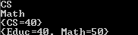

Programming Assignment

- Create a text file "dept.txt" that contains a sequence of department name and number of majors. The department names are assumed to be unique. For example:
Math
50
CS
40
Educ
40
- Write a program to print a list of department name and number of majors sorted in ascending order based on department names. Your program should not perform any sorting operations.
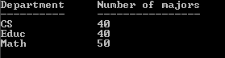

Hand in/email:
- Dept.java

